What if you were following a plan for your money that you KNEW worked? With Dave Ramsey’s class Financial Peace University, you CAN take CONTROL of your money, get out of debt, and create a plan for your future. If you’re interested in learning more about the class, you’re in luck! Because we’re offering classes at Crystal Springs Church of God just for you starting Thursday September 14th at 7PM. For more information, call (269) 925-1843 or go to:
www.crystalspringsfamily.com
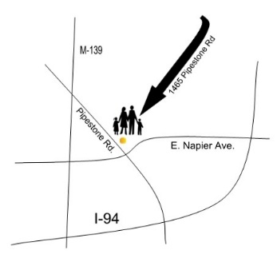

1465 Pipestone Road
Benton Harbor
MI 49022

What if you were following a plan for your money that you KNEW worked? With Dave Ramsey’s class Financial Peace University, you CAN take CONTROL of your money, get out of debt, and create a plan for your future. If you’re interested in learning more about the class, you’re in luck! Because we’re offering classes at Crystal Springs Church of God just for you starting Thursday September 14th at 7PM. For more information, call (269) 925-1843 or go to:
www.crystalspringsfamily.com

1465 Pipestone Road
Benton Harbor
MI 49022

What if you were following a plan for your money that you KNEW worked? With Dave Ramsey’s class Financial Peace University, you CAN take CONTROL of your money, get out of debt, and create a plan for your future. If you’re interested in learning more about the class, you’re in luck! Because we’re offering classes at Crystal Springs Church of God just for you starting Thursday September 14th at 7PM. For more information, call (269) 925-1843 or go to:
www.crystalspringsfamily.com

1465 Pipestone Road
Benton Harbor
MI 49022

